Volumetric calculations

1. A sample of cloudy ammonia is suspected of having been diluted by a

unscrupulous supplier. 100.0 mL of the cloudy ammonia is carefully

and quickly transferred to a 500.0 mL volumetric flask and made up to

500 mL with de-ionised water. A 20.00 mL aliquot of this diluted ammonia

solution was placed in a conical fl ask with several drops of methyl orange.

The ammonia solution was titrated to the methyl orange end point with

0.0500 mol L_1 HCl and the average of three concordant titres was 18.42 mL.

**a**Determine the concentration, in mol L_1, of ammonia in the undiluted

cloudy ammonia sample.

**b**When the label on the cloudy ammonia bottle was checked, it claimed

that the concentration of ammonia was 10 g of ammonia per 100 g of

solution. Was the sample diluted? The density of the cloudy ammonia is 0.9g/mL

1. Aspirin (acetylsalicylic acid) is a weak monoprotic acid. A 300 mg aspirin

tablet was crushed and placed in a conical fl ask together with 25.00 mL of

0.1000 mol L_1 sodium hydroxide and the mixture allowed to react completely

until the tablet had dissolved. Three drops of phenolphthalein were added to

the solution and a pink colour was produced indicating that sodium hydroxide

was in excess.

The excess sodium hydroxide in the fl ask was titrated with 0.0500 mol L_1

HCl and the titre required to reach the phenolphthalein end point was 16.90 mL.

Calculate the percentage purity of the aspirin tablet if the formula of

acetylsalicyclic acid is C9H8O4.

3. Some photographic developing agents contain a base that provides hydroxide ions. A 10.00 mL

sample of developer was diluted to 100.0 mL in a volumetric fl ask. 20.00 mL of this diluted solution was titrated with 0.0900 mol L_1 sulfuric acid and required 21.40 mL to reach a methylorange end point. Calculate the concentration, in mol L_1, of the hydroxide ions in the original developer. (Hint: Sulfuric acid is diprotic.)

4.A patient suffering from indigestion provides a sample of gastric juices for analysis. A 40.00 mL sample of gastric juice was titrated with 0.1050 mol L_1 sodium hydroxide to a phenolphthalein end point. The volume of sodium hydroxide solution required was 17.25 mL. Calculate the pH of the gastric juice in the patient.

**5**A 4.674 g sample of limestone (impure CaCO3) was treated with 375 mL of 0.261 mol L_1hydrochloric acid. After the reaction was over, the mixture was fi ltered and a 25.0 mL sampleof the fi ltrate was titrated with 0.0517 mol L_1 Ba(OH)2 to the phenolphthalein end point.The volume of the barium hydroxide solution required was 17.62 mL.

Calculate the percentage, by mass, of CaCO3 in the limestone sample.

**Volumetric Practice questions**

1. White wine contains a number of weak acids that contribute to the overallcharacter of the wine. However, if too much acid is present, the wine maybecome ‘undrinkable’.In the analysis of one batch of white wine, a chemist titrates the wine withstandard sodium hydroxide solution using phenolphthalein as the indicator.

The results of this experiment are summarised below.

Concentration of standard sodium hydroxide = 0.1030 mol L_1

Aliquot of white wine used = 25.00 mL

Average of three concordant titres = 14.78 mL

Determine the amount, in mole, of H_(aq) available for reaction with a basein a 100 mL sample of this wine.

1. A particular brand of vinegar was analysed to determine the acetic acid content. A 22.17 g sample of the vinegar was diluted (with distilled water) to 250.0 mL in a volumetric fl ask. A 20.00 mL aliquot of 0.1146 mol L_1 sodium hydroxide was placed in a conical flask and titrated with the diluted vinegar solution to a phenolphthalein end point. The average of three concordant titres of diluted vinegar was 33.45 mL. Calculate the percentage by mass of acetic acid in the vinegar
2. Hydrogen peroxide is used as a mild bleaching agent. Analysis of a sample of hydrogen peroxide can be carried out by using potassium permanganate in a redox reaction. While checking a sample of commercial peroxide bleach, a chemist transfers 10.00 mL of the peroxide solution to a 250.0 mL volumetric fl ask and makes it up to the calibrated mark with de-ionised water. A 25.00 mL aliquot of the diluted peroxide solution, mixed with acid, is titrated with a standardised solution of potassium permanganate of concentration 0.018 94 mol L_1. The average of three concordant titres of permanganate is 28.68 mL.

Determinethe concentration of hydrogen peroxide in the commercial bleach solution andthepercentage by mass. Assume the density of the original peroxide bleachis 1.00 g mL_1.

The ionic equation for the reaction is



**Anskey**

**1.**

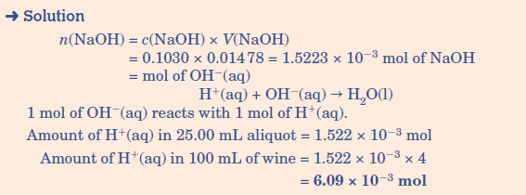

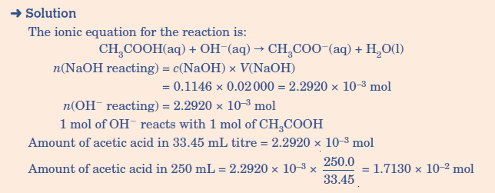**2.**

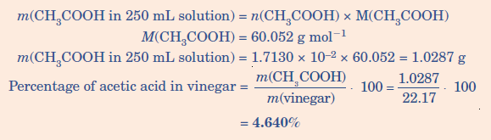

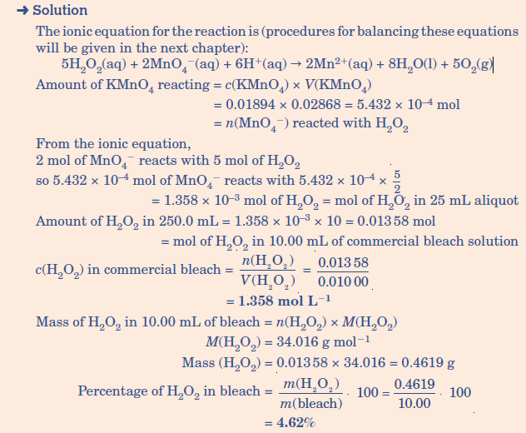**3.**